Q1:  
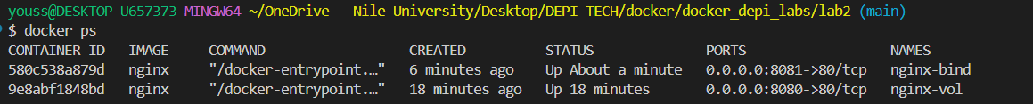  
------------------------------------------------------------------------------------------------------------------

Q2: